UW RGB Colour.wmf

Department of Mechanical and Mechatronics Engineering

Design and Implementation of a Mobile Robot for Formational Traveling Using UWB Localization

**A Report Prepared For:**

The University of Waterloo

**Prepared By:**

Jeyoung Park

378 Beaver Creek Rd

150 University Ave W.

Waterloo, Ontario, N2N 2N2

January 25, 2025

378 Beaver Creek Rd

150 University Ave W.

Waterloo, Ontario, N2N 2N2

January 25, 2025

Prof Andrew Kennings

Director of Mechatronics

Department of Mechanical and Mechatronics Engineering

University of Waterloo

200 University Ave W.

Waterloo, Ontario, N2L 3G1

Dear Professor Kennings,

This report, entitled My Work Report Title, was written to fulfil my 3B work term report requirements. This is my third work report submission.

This report was written entirely by me and has not received any previous academic credit at this or any other institution. I would like to acknowledge the help of Professor Mohammad Biglar Begian, my supervisor and associate professor at Department of Mechanical and Aerospace Engineering, Carleton University, who defined the purpose of the project and helped me choose the test methods. My role in the project was to implement the robotic system, make selections for the components, conduct experiments, and write the report. The project lasted 3 months.

Best Regards

Jeyoung Park

ID: 20934282

3B Mechantronics Engineering

Table of Contents

Summary iv

Introduction 1

Background 2

Hardware Design 4

Software 7

Testing and Validation 12

Kinematics 12

UWB Testing 16

Triangulation Testing 17

Discussion 18

Conclusion 19

References 20

List of Figures

Figure 1: UWB Triangulation Diagram [4] 3

Figure 2: Hardware Components of the Robot 4

Figure 3: HB6 Haisito Balance Charger 6

Figure 4: Web Application for Controlling the Robot 10

Figure 5: Voltage vs V0 14

Figure 6: Voltage vs V1 14

Figure 7: Voltage vs v2 15

Figure 8: Voltage vs v3 15

Figure 9: Testing UWB modules' accuracy 16

List of Tables

Table 1: List of Components 5

Table 2: Directional Control of SPG30E-30K 7

Table 3: STM32 Nucleo F411RE connection to motors 9

Table 4: Robot Speed 13

Table 5: Wheel Speed 13

# Summary

This report discusses the development of a mobile robot system that is designed to demonstrate formational travelling with the use of Ultra-Wideband technology for indoor environments. The goal of this project was to explore and implement robot system that are capable of travelling indoors and being aware of its own locations so that it can be used for robot formational travelling system development.

The focus of the project focused on was implementing UWB-based localization. By utilizing one UWB tag placed on the robot and three fixed UWB anchors in the environment, the system measured distances to the anchors and employed triangulation to calculate the robot’s exact position. Testing of the UWB system showed that the system is reasonably accurate for distances up to 6 meters, with an error margin of up to 30 cm at greater distances and under 10 cm for shorter ranges. Such precision makes UWB localization system to be suitable for indoor applications where GPS is not reliable due to the presence of obstacles or its remote locations.

Another experiments were done to test the accuracy of the triangulation method used in the system. Although raw data cannot be provided due to confidentiality, these experiments confirmed the reliability of the UWB localization system in determining the robot’s position.

Components like the Nucleo F411RE microcontroller, motor drivers, and an 11.1V LiPo battery, which provided power for the system, were used for the hardware. The hardware performed reliably during testing, although proper voltage regulation needs to be ensured to prevent potential damage to the microcontroller due to excessive voltage.

Formational control, which is the ability of multiple robots to maintain coordinated movement, was not fully implemented due to time constraints, but the groundwork has been laid with a reliable localization system in place. Future work can focus on developing a formational control algorithm and enhancing communication between robots to enable real-time change of the formation. Additionally, the integration of obstacle detection and avoidance algorithms will improve the reliability of the system in environments that are unpredictable.

In summary, this project successfully established the foundations for a mobile robot system capable of precise localization and lays the groundwork for future development of fully autonomous, coordinated robot formations.

# Introduction

The goal of this project is to design and implement a mobile robot system to enable formational travelling of multiple mobile robots in future, to be applied to tasks such as automated warehouse management and lab assistance. One of the most challenging part here is that ensuring accurate location and maintaining communication between robots to keep the formation is difficult.

The project seeks to investigate the Ultra-Wideband (UWB) technology for precise localization. Ultra-Wideband (UWB) is a radio technology that uses very low energy levels for short-range, high-bandwidth communications and operates over a wide frequency range [1]. For these advantages, the UWB technology makes itself ideal for indoor positioning in environments in which obstacles are present or GPS signals are inaccessible. The purpose of the project is to implement a robot suitable for indoors formational travelling and to test UWB-based localization. This report discusses the system architecture, including hardware and software design and evaluates the effectiveness of UWB localization system and its impact on the robots’ ability to maintain formation during movement. Communication between different robots and central control systems occurs through WiFi as the system is intended to operate indoors.

To test the robot’s hardware performance and localization capabilities, three experiments are conducted. First, the relationship between the robot's wheel speeds and its movement was tested using the kinematic model. Second, the UWB modules were tested by measuring distance increments of 10 cm to evaluate the accuracy of the UWB-based localization. The error between the expected distance and the measured distance was analyzed to assess how well the UWB system could provide precise positioning data. Third, how well the UWB based triangulation system can calculate the robot’s position within a controlled environment was assessed by varying the location of the robot.

# Background

Developing robots that are capable of moving in formation requires precise localization and control algorithms. As mentioned in the introduction section, this project utilizes Ultra-Wideband (UWB) technology for accurate indoor localization, triangulation for determining the robot's position and formational control for coordinated movement in future. While the UWB-based localization was implemented successfully, formational control could not be fully integrated due to time constraints. Below, the majors technological backgrounds used for this project is discussed.

Ultra-Wideband (UWB) is a radio frequency technology that operates over a broad spectrum of frequencies, typically between 3.1 and 10.6 GHz, and is capable of transmitting data at high rates with low power consumption. One of the defining features of UWB is its ability to provide highly accurate distance measurements by using Time of Flight (ToF) calculations. UWB transmits short, high-frequency pulses between devices, and the distance between two points is calculated by measuring the time it takes for the signal to travel between them [2].

This makes UWB a good technology to be used for indoor positioning, where GPS signals are weak or unavailable. UWB's accuracy, which usually comes with an error within 10 to 30 centimeters, is significantly better than other indoor localization technologies like WiFi or Bluetooth. In this project, UWB modules were used to measure the distance between a mobile robot (equipped with a UWB tag) and three fixed UWB anchors located elsewhere in the room [2].

Triangulation is used to determine the position of an object, the robot in this case, by measuring its distances from multiple anchors, three in the case of this project, with their positions known. In this system, three UWB anchors are placed in fixed locations within the environment, and the distances between the robot's UWB tag and the anchors are measured. By applying triangulation, the robot’s precise position can be calculated.

In triangulation, each anchor measures the distance to the robot’s UWB tag. With three distance measurements, the robot's position can be pinpointed using geometry. The technique relies on basic principles of circles: with three circles drawn using the measured distances as radii and the anchors as centers, the intersection point of the circles corresponds to the robot’s position [3]. This method is widely used in various localization systems, especially in indoor environments where external positioning systems like GPS cannot be used.

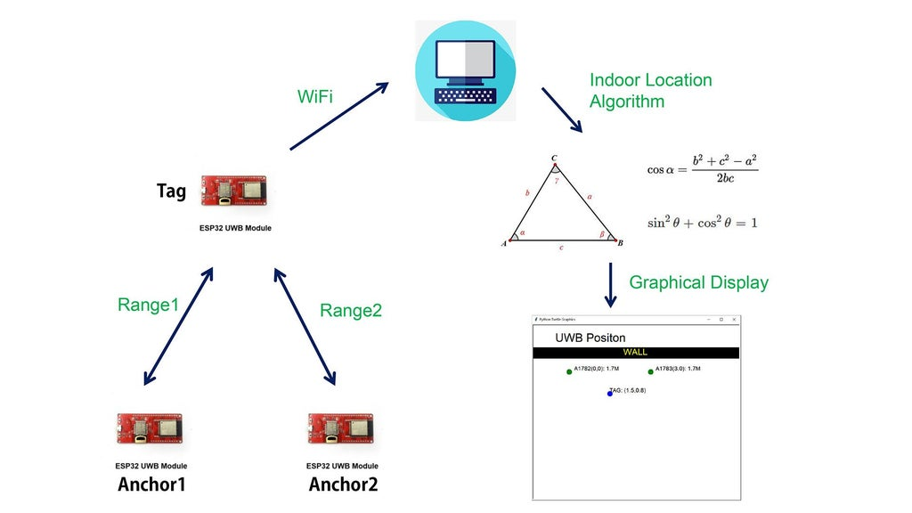

Figure 1: UWB Triangulation Diagram [4]

Formational control involves coordinating the movements of multiple robots to maintain a specific formation as they move through an environment. Each robot adjusts its position based on the positions of its neighboring robots, ensuring that the formation remains constant. This technique is useful in applications such as automated warehouse management, search and rescue missions, and swarm robotics [5].

Formational travelling of robots requires both accurate localization and real-time communication between the robots. In this project, UWB-based localization was intended to provide the precise position data necessary for each robot to alter its position relative to the others. However, due to time constraints, the formational control algorithm was not implemented. The groundwork for accurate localization using UWB has been laid, but the coordination of multiple robots to maintain formation remains a task for future development.

# Hardware Design

Figure 2: Hardware Components of the Robot

The hardware design of the mobile robot is import so that the robot performs its tasks as intebded. Each component was selected to achieve high power efficiency, precision control, and effective communication. The table below is a list of components used for the mobile robot.

Table 1: List of Components

|  |  |
| --- | --- |
| **Item** | **Quantity** |
| Nucleo F411RE | 1 |
| L293B | 2 |
| SPG30E-30K | 4 |
| LM2596 DC-DC Buck Converter | 1 |
| CNHL LiPo Battery | 1 |
| ESP32 | 1 |
| DWM1000 | 1 |

For the microcontroller, STM32 Nucleo F411RE was chosen for the project as it provides several advantages over boards like Arduino and Raspberry Pi. The STM32 Nucleo F411RE offers significantly higher processing power compared to most Arduino boards and is more suitable for high precision calculations; and most importantly, it provides more peripherals such as multiple UARTs, SPI, I2C, and PWM outputs, which are necessary for integrating different sensors and controlling multiple motors [6].

To control the movement, the L293B motor drivers are used. Each motor driver can control the speed and direction of up to two SPG30E-30K motors by regulating the current flow [7]. SPG30E-30K motors, on the other hand, were selected for their compact size and torque, which are well suited for moving small, lightweight robots [8]. Four motors in total ensure that the robot is capable of travelling in all four directions and rotating.

The robot is powered by a CNHL LiPo battery, which is not only lightweight but also is powerful and reliable. The advantages of LiPo (Lithium Polymer) batteries are their high energy density, meaning they can store huge amount of energy for their weight [9]. This is essential for this project’s mobile robots as they need to be able to move in agile manner. The 11.1V LiPo battery provides enough energy to power both the motors and the Nucleo F411RE microcontroller without significantly increasing the weight of the robot. Below is the balance charger used to charge the LiPo batteries.

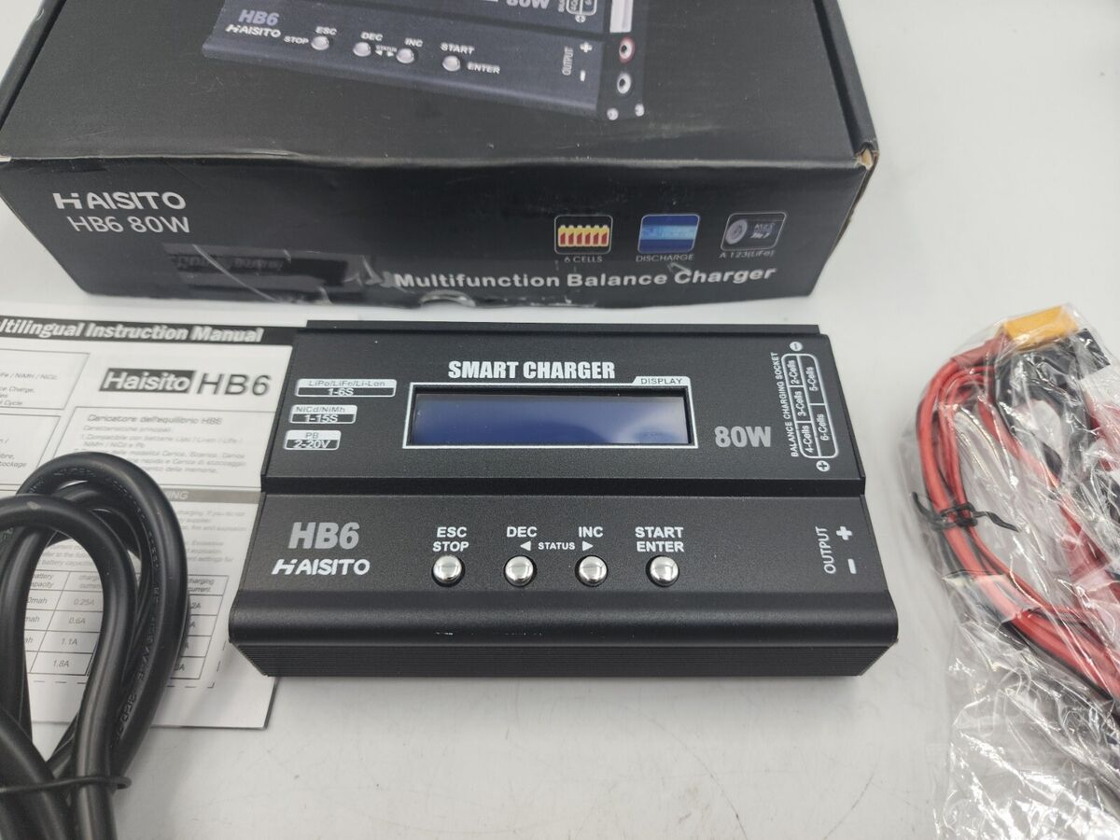

Figure 3: HB6 Haisito Balance Charger

Most importantly, for UWB board, Makerfabs ESP32 UWB module with DW1000 was chosen for this project due to its communication capabilities, processing power, and integration with Ultra-Wideband (UWB) technology. The ESP32 is equipped with WiFi module, which is important for the robot’s ability to communicate wirelessly with other robots indoors. The WiFi capability allows for real-time data transmission between robots or to a central controller, making it easier to manage the robot’s formation and share UWB positioning data. The way robots communicate with each other will be discussed more in detail in the Software Design section [10].

# Software

The software for the mobile robot system was designed to control the movement of the robot, process motor control commands, handle communication for receiving commands, and regulate PWM signals used to drive motors. Nucleo F411RE is tasked to control motors based on signal from ESP32, while ESP32 connected to UWB board communicates with other robot and central control unit and receives distance data from the UWB board.

As mentioned earlier, the motor control is conducted by STM32 Nucleo F411RE board and is implemented using PWM signals to adjust speed of the motors. The PWM signals are generated by TIM1 and TIM4 timers. Each timer corresponds to one of the four motors, and the duty cycle of the PWM cycle of the PWM signal determines the motor’s speed.

The motor supports both forward and backward movement, and the direction of the motor is controlled by triggering the corresponding GPIO. Depending on the received command, the robot moves forward or backward by setting the GPIO pins for each motor's direction and adjusting the PWM duty cycle for speed control. Below table [8] is for controlling the direction of SPG30E-30K motor:

Table 2: Directional Control of SPG30E-30K

|  |  |  |
| --- | --- | --- |
| **GPIO Pin 1** | **GPIO Pin 2** | **Motor Direction** |
| High | Low | Clockwise |
| Low | High | Counterclockwise |
| Low | Low | Stop |
| High | High | Stop |

The motor is designed to support precise adjustments in speed based on incoming commands. The PWM duty cycle is calculated as a percentage of maximum speed (255), and the calculated value is applied to the appropriate timing channels.

Communication with the ESP32 is handled using UART or Universal Asynchronous Receiver Transmitter, with USART2 serving as the communication interface. The UART operates at 9600 baud rates. The system receives motor control commands via UART in the form of string containing three integers: function ID that determines whether the robot moves forward/backward or sideways, speed from 0 to 255, direction that determines whether if the robot moves forward/right or backward/left, depending on function ID.

The system uses interrupt driver UART to ensure that commands are executed without delay. Interrupt callback function is triggered whenever a complete command is received. This function processes the incoming data, turns them into three separate integer variables, and passes them to the function that executes motor control as written above.

A safety feature is implemented to stop all motor activity if an invalid command or no command is received for a certain amount of time. The stop function, when triggered, ensures that all GPIO pins controlling the motors are reset and the PWM signals are set to zero. This makes sure that the motors are halted and thus the robots stop moving if a communication error occurs, the robot’s connection with the controller is lost, or something unexpected happens.

Table 3: STM32 Nucleo F411RE connection to motors

|  |  |
| --- | --- |
| **Pin** | **Function** |
| PA0 | Motor 1 Pin 1 |
| PA1 | Motor 1 Pin 2 |
| PA8 (TIM1_CH1) | Enable Pin 1 |
| PA4 | Motor 2 Pin 1 |
| PA5 | Motor 2 Pin 2 |
| PA9 (TIM1_CH2) | Enable Pin 2 |
| PB0 | Motor 3 Pin 1 |
| PB1 | Motor 3 Pin 2 |
| PA10 (TIM1_CH3) | Enable Pin 3 |
| PB10 | Motor 4 Pin 1 |
| PB12 | Motor 4 Pin 2 |
| PB6 (TIM4_CH1) | Enable Pin 4 |

The embedded software for the ESP32 connected to the WiFi and UWB modules integrates several important functionalities, including UART communication for transmitting commands for the Nucleo board, web server operations, and UWB distance measurement. The system operates in real-time and is organized into tasks running in parallel using FreeRTOS.

The ESP32 connects to a Wi-Fi network and acts as a server to receive control commands through a web interface. The web server handles incoming user inputs and processes HTTP POST requests to receive three numerical inputs from the user. These values, as mentioned, are then transmitted via UART to the Nucleo board. This allows for remote control of the robot’s motors based on the web-based inputs.

Figure 4: Web Application for Controlling the Robot

The most critical part of this system, as stressed multiple times, is the use of UWB technology for locating the robot in a room. The UWB module attached to ESP32 acts as a tag, while three other UWB modules are placed in fixed positions around the room acts as anchors. By measuring the distance between the UWB tag on the robot and the three anchors, the system uses triangulation to calculate the robot’s exact position in the room. The system continuously updates the robot’s location based on distances received from the anchors.

Once the robot’s location is determined using triangulation, the robot can calculate its relative position with respect to other robots to enable formational travelling.

Since the ESP32 is assigned to multiple tasks – handling webserver for user inputs, communicating with the Nucleo board for motor control, and measuring distances from UWB modules acting as anchors, FreeRTOS is used to allow the board to perform multiple tasks concurrently. By using FreeRTOS, the system can run various independent tasks without one task blocking the other.

FreeRTOS works by creating and managing multiple tasks that use the CPU’s computer power. In this system, two main tasks created are taskServer and taskUWB. The first task, as its name implies, is responsible for managing the ESP32’s web server functionality, allowing the user to send commands to the robot through a web interface by listening for incoming HTTP client connections, processing requests, and updating the motor control variables via UART.

The second critical task, taskUWB, handles UWB-based localization. It continuously reads from the UWB module the distance data from three fixed anchors placed in the room. This task also applies a calibration function of DW1000Ranging library to the raw UWB data to improve the accuracy of the distance measurements. Once distances from the anchors are found, it moves on to the part of determining the location of the robot with the triangulation method.

TaskServer is assigned a high priority in the system as it manages the ESP32’s web server functionality, allowing users to control the robot’s motor through web interface. This ensures that user inputs are processed immediately without delay, making the system responsive to remote commands and ensuring safety. While UWB localization is crucial for accurate movement and the performance of the system, it can afford to run with slight delays significantly impacting the overall system.

# Testing and Validation

## Kinematics

In this experiment, the relationship between the robot’s wheel speeds and its movement was tested using the kinematic model. The intended purpose of this experiment is to assess how linear does the speed of the wheels increase relative to the inputted voltage to the motors.

The relationship between the wheels speed , , and , with robot speed and , are defined below.

Equation 1: Kinetics of the Wheels

and each stand for forward robot linear velocity, sideway robot linear velocity and the robot angular velocity.

Below is collected data for and values each corresponding to PWM inputs for speed.

Table 4: Robot Speed

|  |  |  |  |  |
| --- | --- | --- | --- | --- |
| **PWM value** | **Voltage (V)** | **(cm/s)** | **(cm/s)** | **(rad/s)** |
| 48 | 0.94 | 2.8 | 3.3 | 0.43 |
| 64 | 1.25 | 7.8 | 10.5 | 0.69 |
| 80 | 1.57 | 16.7 | 19.2 | 0.95 |
| 96 | 1.88 | 24 | 28.6 | 1.21 |
| 112 | 2.20 | 30.8 | 33.8 | 1.47 |
| 128 | 2.51 | 37.6 | 41.2 | 1.73 |
| 144 | 2.82 | 41 | 47.2 | 1.99 |
| 160 | 3.14 | 48 | 55.8 | 2.25 |
| 176 | 3.45 | 53.2 | 59.6 | 2.51 |
| 192 | 3.76 | 62.8 | 65.2 | 2.77 |
| 208 | 4.08 | 67 | 70 | 3.03 |
| 224 | 4.39 | 71.2 | 75 | 3.29 |
| 240 | 4.71 | 79.8 | 81.6 | 3.55 |
| 255 | 5 | 84.4 | 92.2 | 3.81 |

With the use of equation above, the wheels speed , , and are calculated.

Table 5: Wheel Speed

|  |  |  |  |  |  |
| --- | --- | --- | --- | --- | --- |
| **PWM value** | **Voltage (V)** | **(cm/s)** | **(cm/s)** | **(cm/s)** | **(cm/s)** |
| 48 | 0.94 | 6.16 | 0.055 | -0.44 | 5.66 |
| 64 | 1.25 | 15.08 | -3.22 | -5.92 | 12.38 |
| 80 | 1.57 | 25.51 | -10.39 | -12.89 | 23.01 |
| 96 | 1.88 | 36.63 | -15.97 | -20.57 | 32.03 |
| 112 | 2.20 | 43.56 | -21.04 | -24.04 | 40.56 |
| 128 | 2.51 | 52.59 | -26.11 | -29.61 | 49.09 |
| 144 | 2.82 | 60.41 | -27.79 | -33.97 | 54.21 |
| 160 | 3.14 | 70.74 | -33.06 | -40.86 | 62.94 |
| 176 | 3.45 | 76.27 | -36.53 | -42.93 | 69.87 |
| 192 | 3.76 | 83.59 | -44.41 | -46.81 | 81.19 |
| 208 | 4.08 | 90.12 | -46.88 | -49.88 | 87.12 |
| 224 | 4.39 | 96.85 | -49.35 | -53.15 | 93.05 |
| 240 | 4.71 | 105.17 | -56.23 | -58.03 | 103.37 |
| 255 | 5 | 117.50 | -59.10 | -66.90 | 109.70 |

Below are charts for voltage given for speed over the wheel speed.

Figure 5: Voltage vs V0

Figure 6: Voltage vs V1

Figure 7: Voltage vs v2

Figure 8: Voltage vs v3

## UWB Testing

The objective of this test was to see the accuracy of UWB positioning system by measuring distance between increments of 25 cm, from 0.5 meters to 6 meters, and analyzing the error in the measured distance. Two of the ESP32 UWB modules were used as a transmitter and a receiver. Due to confidentiality constraints, the actual data from the experiment cannot be provided; however, the findings from the experiment can be summarized.

The UWB system’s distancing functionality was tested by placing two UWB modules at known distances apart, increasing the distance in increments of 25 cm, and recording the measured distance from the UWB module. Up to a range of 2.5 meters, the UWB system consistently performed reasonably well, typically maintaining a distance error less than 10 cm, while the system achieved a distance error of 30 cm from a range of 2.5 meters to 6 meters. Beyond 6 meters, however, there was a noticeable increase in error and fluctuations in the measured data. Despite this increase of error at longer ranges, the UWB system provided reliable and consistent results within the critical 6 meters range, especially the technology is to be used indoors and indoor spaces’ diameters usually do not exceed 6 meters.

Figure 9: Testing UWB modules' accuracy

## Triangulation Testing

Another experiment was conducted to test the accuracy of the robot localization system. The purpose of this experiment was to figure out how well the UWB triangulation system can calculate the robot's position while keeping the UWB anchors in fixed positions to measure their distances from the robot a certain set position.

A 5x5 meter indoor space was used for the experiment, with three UWB anchors placed at fixed, known locations at the corners of the room. The robot, connected to a UWB tag, was moved to different locations within the environment. At each of the locations, the UWB tag on the robot measured the distances to the three fixed UWB anchors. These distances were then used to calculate the robot's position using triangulation. The calculated position was compared to the robot’s actual known position to evaluate the accuracy of the localization system.

Due to confidentiality reasons, the raw data from this experiment cannot be provided. However, the results showed that the UWB triangulation system accurately calculated the robot’s position with an error less than 30 cm throughout the experiment, which is acceptable. The experiment validated the system’s ability to maintain reliable localization of the robots, supporting the claim that UWB technology can be used to later implement formational travelling of multiple robots.

# Discussion

The project’s purpose was to develop indoor mobile robot system that is capable of locating individuals robots with the use of UWB technology so that a system in which mobile robots travel in formation can be implemented in future. Through the testings conducted, the performance of the developed system is demonstrated.

The UWB based localization has been proven to be practical as it can locate individual robots with a reasonable accuracy. Up to the distances of 6 meters, the UWB modules were able accurately estimate the distance from one another with a distance error of up to 30 cm. Not only that, when the robot’s location in lab was estimated, the localization system that used triangulation was able to locate the robot with an accuracy of 30 cm in both x and y direction, which proves that this system is precise enough to be applied to the development formational control of multiple robots.

For formational control, while the system was not fully implemented due to time constraints, the groundwork was laid with the accurate localization system. The primary focus of formational control is maintaining the relative positions of robots in the formation. An error up to 30 cm is still practical for most applications, as will not lead to significant confusion in relative positions that would lead collisions or collapse of the formation.

The hardware components of the robot system, including the STM32 Nucleo F411RE microcontroller, motor drivers, and 11.1V LiPo battery, performed reliably during the testings. The STM32 Nucleo F411RE provided sufficient processing power to manage real-time motor control and process UWB data without noticeable delays. The 11.1V LiPo battery supplied sufficient amount of power, supporting the motors and control systems over the experiments without the need for frequent recharging.

However, one key issue that emerged was the potential risk of voltage mismatch. The microcontroller boards can only accept up to 5V, while the battery provides 11.1V, requiring careful voltage regulation. If the voltage is not properly stepped down, there is a risk of damaging the sensitive electronics. This highlights the need for robust power management systems, such as DC-DC buck converters, to safely regulate voltage across different components.

# Conclusion

The experiments conducted during this project showed that UWB technology is well-suited for indoor robot localization, providing high accuracy in real-world environments. The triangulation method proved to be effective for determining the robot’s indoor positions. While formational control was not fully implemented, the foundation has been laid for future development. The hardware system, despite minor risks of burning boards and circuits, performed reliably. Overall, the project demonstrates the feasibility of using UWB localization for coordinated mobile robot movement and offers a solid base for further development of formational control systems.

# References

|  |  |
| --- | --- |
| [1] | S. Stroh, "ULTRA-WIDEBAND: MULTIMEDIA UNPLUGGED," 1 Sep 2003. [Online]. Available: https://cmailcarletonca-my.sharepoint.com/:w:/r/personal/mohammadbiglar_cunet_carleton_ca/Documents/Research/Active%20Projects/Multiple%20Mobile%20Robots/Reports/Multiple%20Robots%20Project.docx?d=w5fbb2f8b14d9424da350469ca02e9ec1&csf=1&web=1&e=55ybcJ. |
| [2] | Decawave, "DWM1000 Module Datasheet.," 2017. |
| [3] | G. B. Jeffrey Hightower, Location Systems for Ubiquitous Computing, Seattle, 2001. |
| [4] | Makerfabs, "ESP32 UWB Indoor Positioning Test," [Online]. Available: https://www.instructables.com/ESP32-UWB-Indoor-Positioning-Test/. [Accessed 23 Sep 2024]. |
| [5] | R. C. A. Tucker Balch, Behavior-based formation control for multirobot teams, 1998. |
| [6] | STMicroelectronics, "STM32 Nucleo-64 development board with STM32F411RE MCU, supports Arduino and ST morpho connectivity," [Online]. Available: https://www.st.com/en/evaluation-tools/nucleo-f411re.html. [Accessed 23 Sep 2024]. |
| [7] | STMicroelectronics, "L293B Push-Pull Four Channel Drivers," [Online]. Available: https://www.st.com/en/motor-drivers/l293b.html. [Accessed 23 Sep 2024]. |
| [8] | Cytron Technologies, "MO-SPG-30E-xxxK User's Manual," 2020. |
| [9] | K. Bonheur, "Advantages and Disadvantages of Lithium Polymer Batteries," 2 Jan 2022. [Online]. Available: https://www.profolus.com/topics/advantages-disadvantages-lithium-polymer-batteries/. [Accessed 23 Sep 2024]. |
| [10] | Makerfabs, "ESP32 UWB(Ultra Wideband)," [Online]. Available: https://www.makerfabs.com/esp32-uwb-ultra-wideband.html. [Accessed 23 Sep 2024]. |
| [11] | Qorvo, "DWM1000 Data Sheet". |
| [12] | Mapsted Blog, "UWB Positioning Explained – Everything You Need to Know About it Before Implementing," 1 Jan 2024. [Online]. Available: https://mapsted.com/en-ca/blog/uwb-positioning-explained. [Accessed 10 Jun 2024]. |